Name – Bhavna Latare

Subject – CO406U

Date- 10 January 2022

**EXTERNAL EXAM**

**Aim -** Write a program to recognize strings under ‘a*’, ‘a*b+’, ‘abb’.

**Algorithm –**

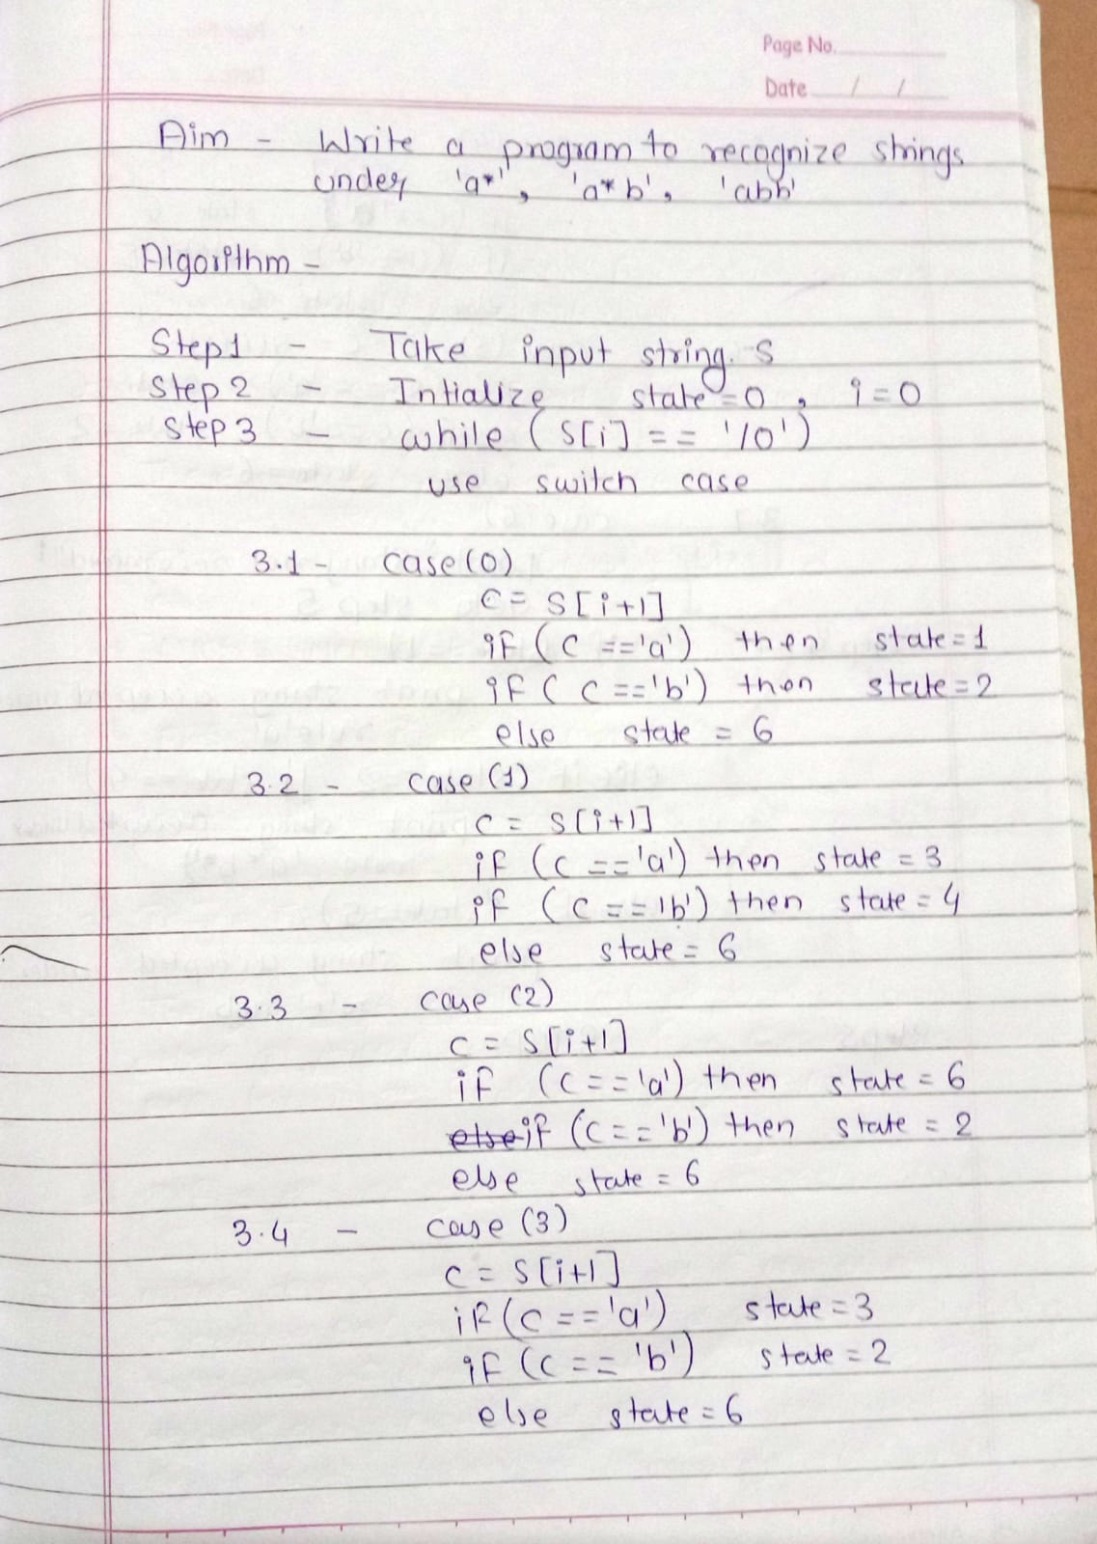

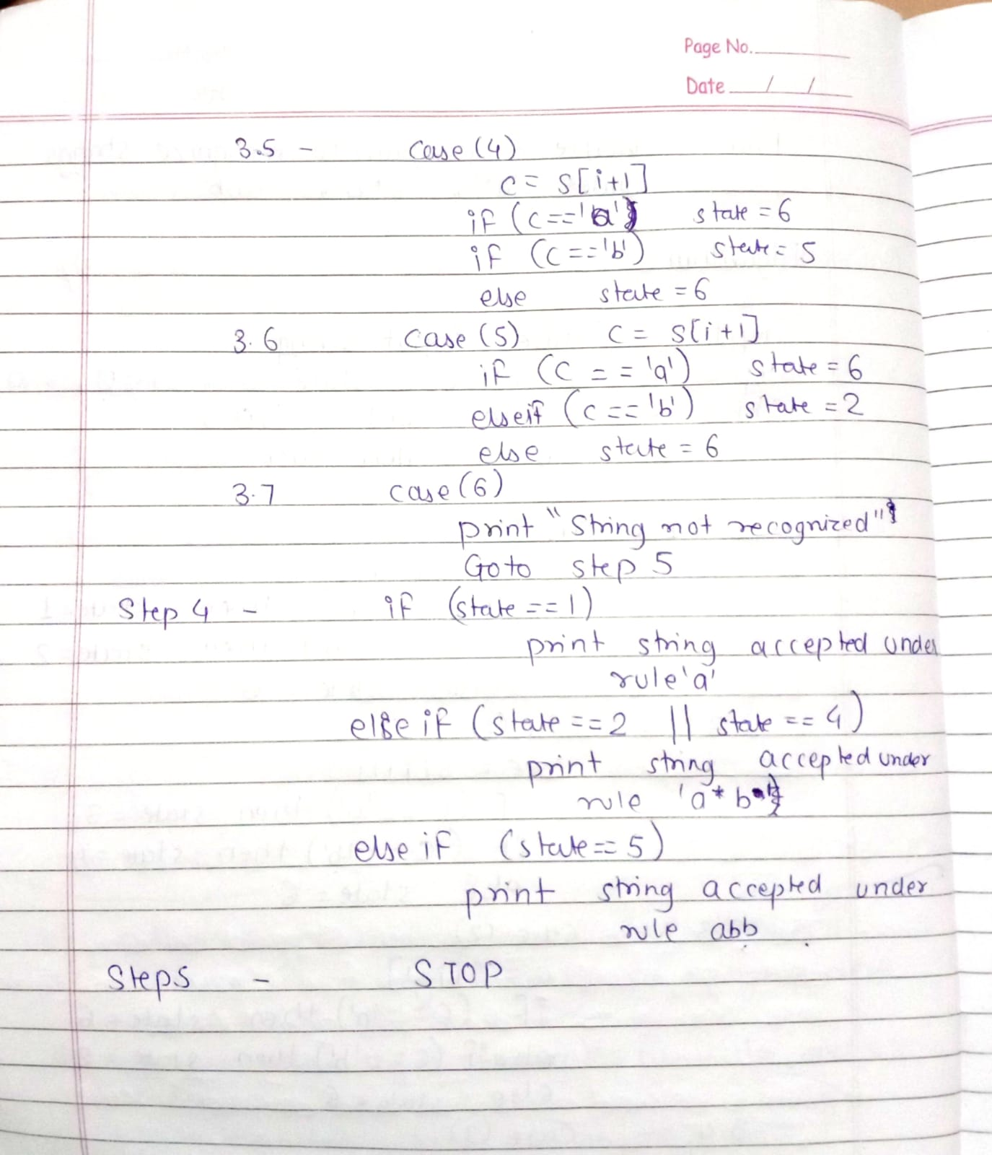

**Flowchart –**

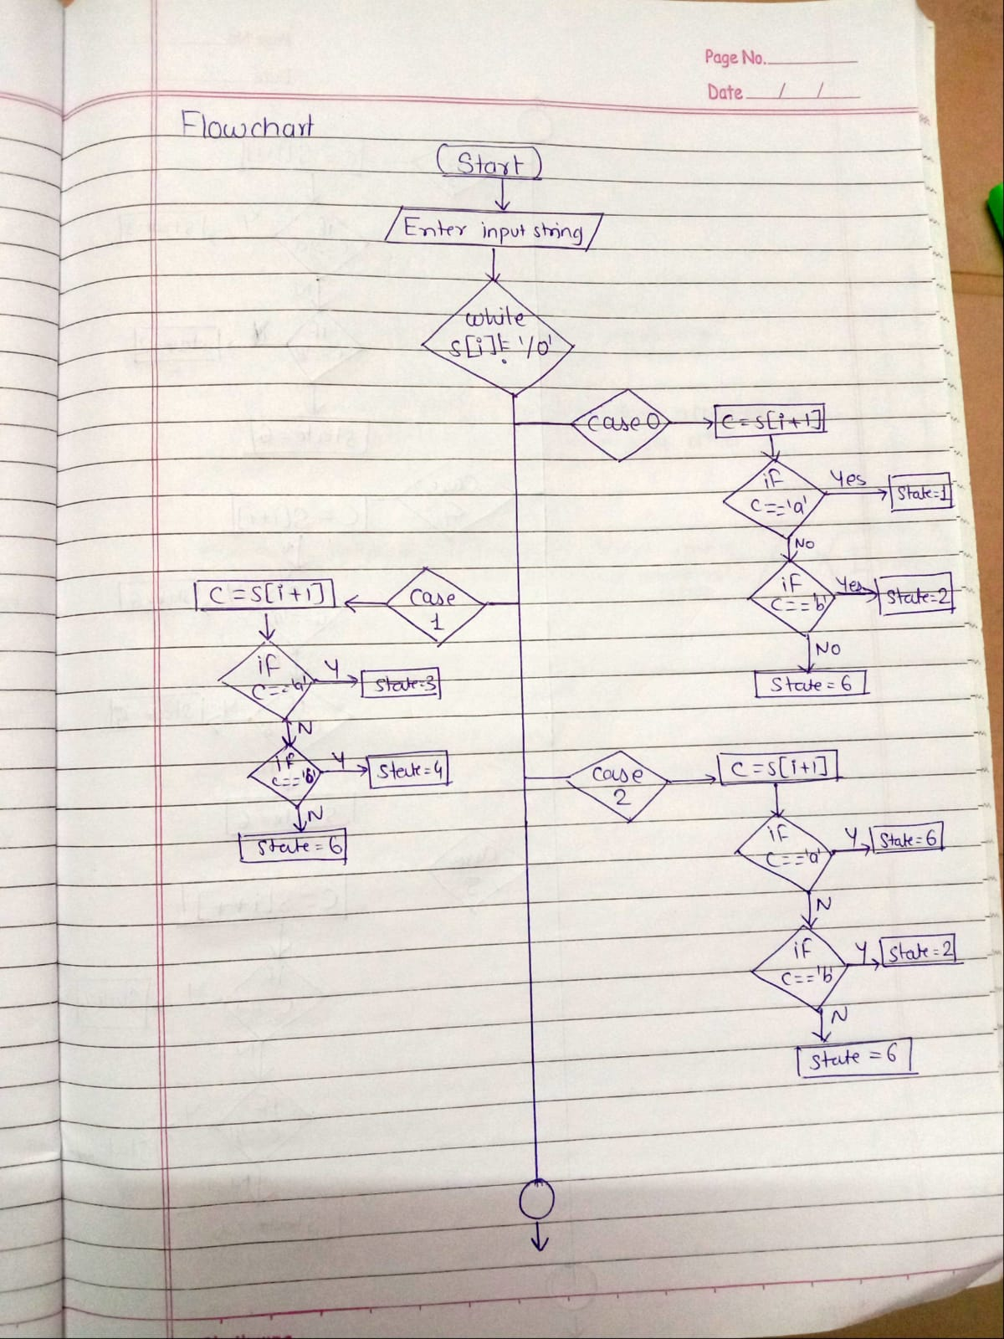

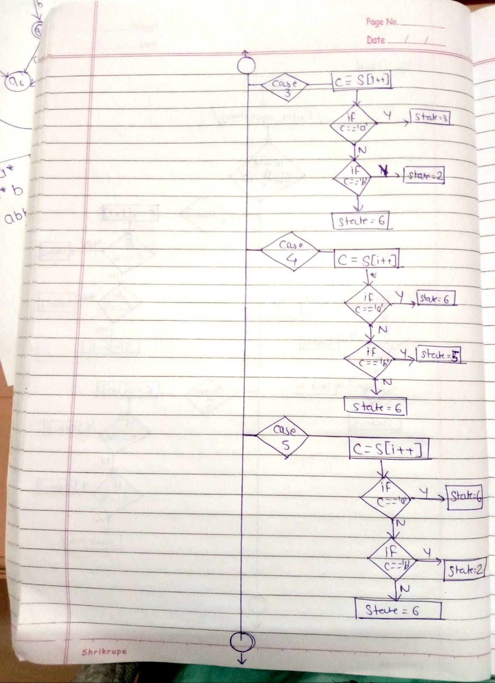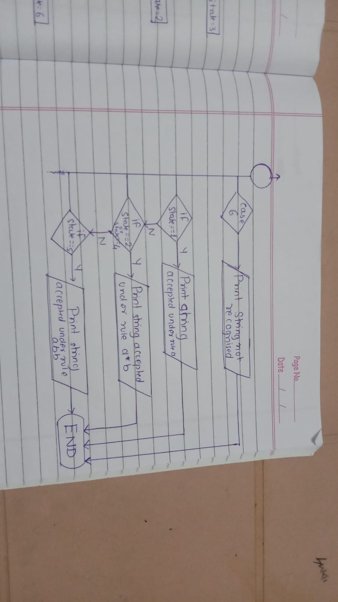

**DFA –**

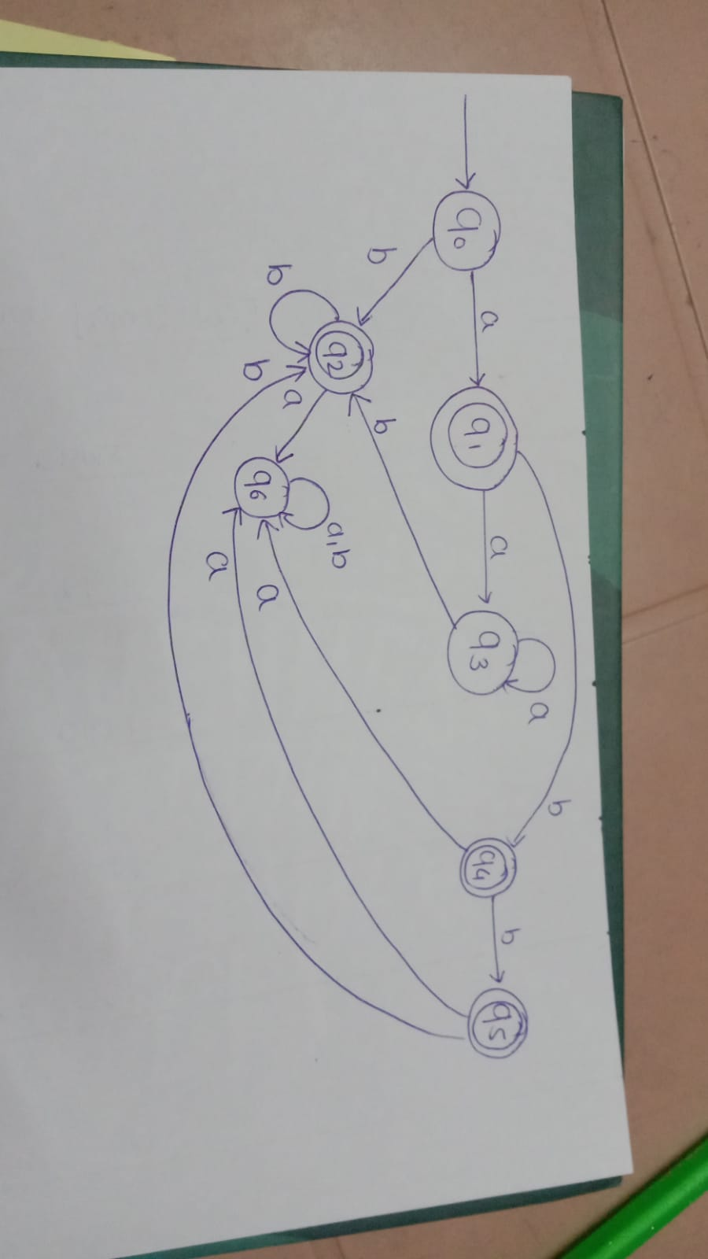

**Code –**

#include<stdio.h>

#include<string.h>

#include<stdlib.h>

void main()

{

char s[20],c;

int state=0,i=0;

printf("\n Enter a string :- ");

gets(s);

while(s[i]!='\0')

{

switch(state)

{

case 0: c=s[i++];

if(c=='a')

state=1;

else if(c=='b')

state=2;

else

state=6;

break;

case 1: c=s[i++];

if(c=='a')

state=3;

else if(c=='b')

state=4;

else

state=6;

break;

case 2: c=s[i++];

if(c=='a')

state=6;

else if(c=='b')

state=2;

else

state=6;

break;

case 3: c=s[i++];

if(c=='a')

state=3;

else if(c=='b')

state=2;

else

state=6;

break;

case 4: c=s[i++];

if(c=='a')

state=6;

else if(c=='b')

state=5;

else

state=6;

break;

case 5: c=s[i++];

if(c=='a')

state=6;

else if(c=='b')

state=2;

else

state=6;

break;

case 6: printf("\n %s is not Recognised By the Automata.",s);

exit(0);

}

}

if((state==1)||(state==3))

printf("\n %s is Accepted under rule 'a*'.",s);

else if((state==2)||(state==4))

printf("\n %s is Accepted under rule 'a*b+'.",s);

else if(state==5)

printf("\n %s is Accepted under rule 'abb'.",s);

}

**Output –**

